Energy Skate Park Lab

DIRECTIONS
- Complete the following virtual lab activity - “Energy Skate Park” with a partner to better understand potential and kinetic energy.
- Click on the Intro tab/screen. Notice that there are 3 tracks listed.
- Run the track that each question is requiring your group to use.
- Select the speed box so the speedometer shows up, The Grid so you know what height the skater is at, The Bar Graph to identify maximum potential and kinetic energy, a pie chart to identify each potential and kinetic energy outcome.
- NOTE: GAVITATIONAL POTENTIAL ENERGY = (MASS OF THE OBJECT) x (GRAVITY CONSTANT) x (HEIGHT OF THE OBJECT)

QUESTIONS (U SHAPED TRACK):

- What is the definition of potential energy? When does the skater have maximum potential energy within the U shaped track (Take a picture and describe if necessary)?

- What is the definition of kinetic energy? When does the skater have maximum kinetic energy within the U shaped track (Take a picture and describe if necessary)?

- Describe how the Bar Graph keeps track of the skater’s potential and kinetic energy while the skater changes position within the track. Explain with a picture and words.

- Take two to three pictures with your iPad of the skater skating on the U-shaped track. Below your pictures, describe why the bar graph reads if the skater has more potential or kinetic energy while the skater is changing position.

- What type of potential energy is being used within the skate park? Why do you think it is this type of potential energy?

QUESTIONS (W – Shaped Track):

- Put the skater on top of the track. Does the skater’s potential and kinetic energy change throughout the journey? Explain your reasoning with pictures and words.

- Reset your data given on the track. Increase the mass of the skater. Describe what has happened to the kinetic and potential energy of the skater. Explain your reasoning with pictures and words.

- Reset your data on the track. Instead, decrease the mass of the skater. Describe what has happened to the kinetic and potential energy of the skater. Explain our reasoning with pictures and words.

- Why do you suppose changing the mass of the skater changes the potential and kinetic energy of the skater? Explain your reasoning with the gravitational potential energy equation (remember “Hoodwinked”)

READ: One of Einstein’s Laws: Energy is not created or destroyed; it is simply transformed from one form to another. This is the law of conservation of energy. It is not the same thing as “conserving energy”, which implies that we need to limit our energy usage and use our resources wisely. The conservation of energy is one of the most important ideas in science.

QUESTIONS (CREATE A TRACK):
10. Create a track that resembles the example below. Each Dot represents a letter from A to G (In the example, the skater is at point A).
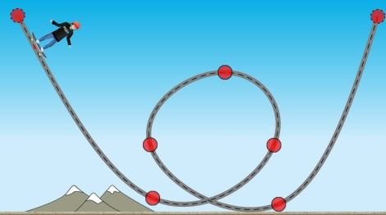

  - Pause the simulation, and place the skater at point A. Take a picture, and record what you see.

  - Pause the simulation, and place the skater at point B. Take a picture, and record what you see.

  - Pause the simulation, and place the skater at point E. Take a picture, and record what you see.

- Now, increase the friction of the track. Play the simulation. What do you notice about both potential and kinetic energy bar graph readings? Explain your reasoning with pictures and words.

- What are some advantages to representing both potential and kinetic energy with bar graphs?

- What are some advantages to representing the energy with potential and kinetic energy pie charts?

QUESTIONS (CREATE A TRACK):
14. Create a track of your own. Make sure you take a picture of your track when you are finished. An example is shown below.
B
D
C
A

15.Describe the energy transfer throughout your given track. Use both the bar graphs and pie charts for better understanding of the transfer of energy from potential to kinetic.

